BREAKFAST CHATTER
Weekly Bulletin of Rotary Club of Kathmandu Mid-Town
District 3290 Volume No. 15/16 for #758 November 05, 2004
www.rotarymidtown.org.np
NOVEMBER IS ROTARY FOUNDATION MONTH

SUNSHINE ANNOUNCEMENT FOR THE WEEK OF 05 NOVEMBER 2004;
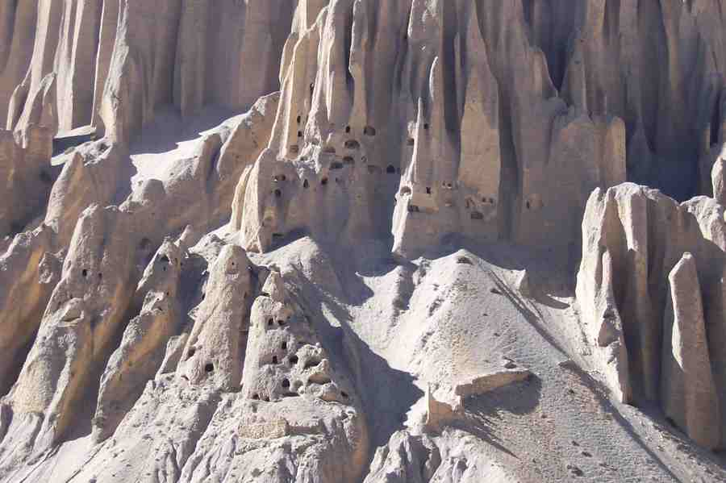
Our Tibetan explorer, Peter Clawson, celebrates his birthday on the 5th. Can you see him waving from his cave? We wish him a cozy celebration as he prepares for the cold weather. To wish him well, try pekaynepal@hotmail.com

*******************

MEETING ACTIVITIES:
DATE | ACTIVITY | SUBJECT
5 NOV | Biswajit Chakraborty | EcoTourism and the hotel industry
12 NOV | to be named | topic to be announced
19 NOV | possibly shift to | evening Charter Night celebration
26>>28 NOV | possibly shift to | dinner Sunday the 28th to welcome Taiwan group

****************
NEWS …… As noted above two significant events are coming around the 19th and 28th. This will be discussed at tomorrow’s meeting.

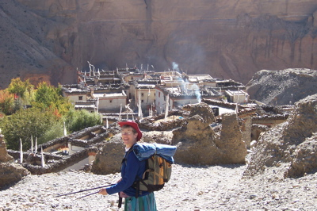
****************
THIS WEEK’S PRESENTATION BY BISWAJIT CHAKRABORTY
Born in 1963, Biswajit earned his Bachelor’s and Master’s degrees in commerce and continued on with extensive service with the Taj/Oberoi. Earlier this year he served as Regional Director of sales and marketing for the Hilton, and now has come to Kathmandu as the Yak and Yeti’s General Manager. We welcome his thoughts on bringing more EcoTourists to Nepal.
**************** YIR…David

